Andre Hardy – Project 5-1

6. Navigate to the location of the download and open the image. Is there anything you can tell by looking at this code? How could threat actors use this to their advantage? Where could malicious QR codes be used? Is there any protection for the user when using QR codes?
A: There is nothing identifying about the QR code itself. Threat actors could use this to their advantage as unsuspected users have no clue their code could be malicious. Malicious QR codes could be used anywhere such as restaurants, libraries, or airports. Users’ best protection is not to scan unknown QR codes or ensure their legitimacy with the owner/creator prior to scanning.

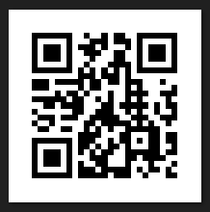
11. What does the text box display? How could an attacker use a QR code to direct a victim to a malicious website?
A: The text box displays the URL for the QR code. Attackers can create QR codes of their malicious webpage URLs and embed them in public locations.
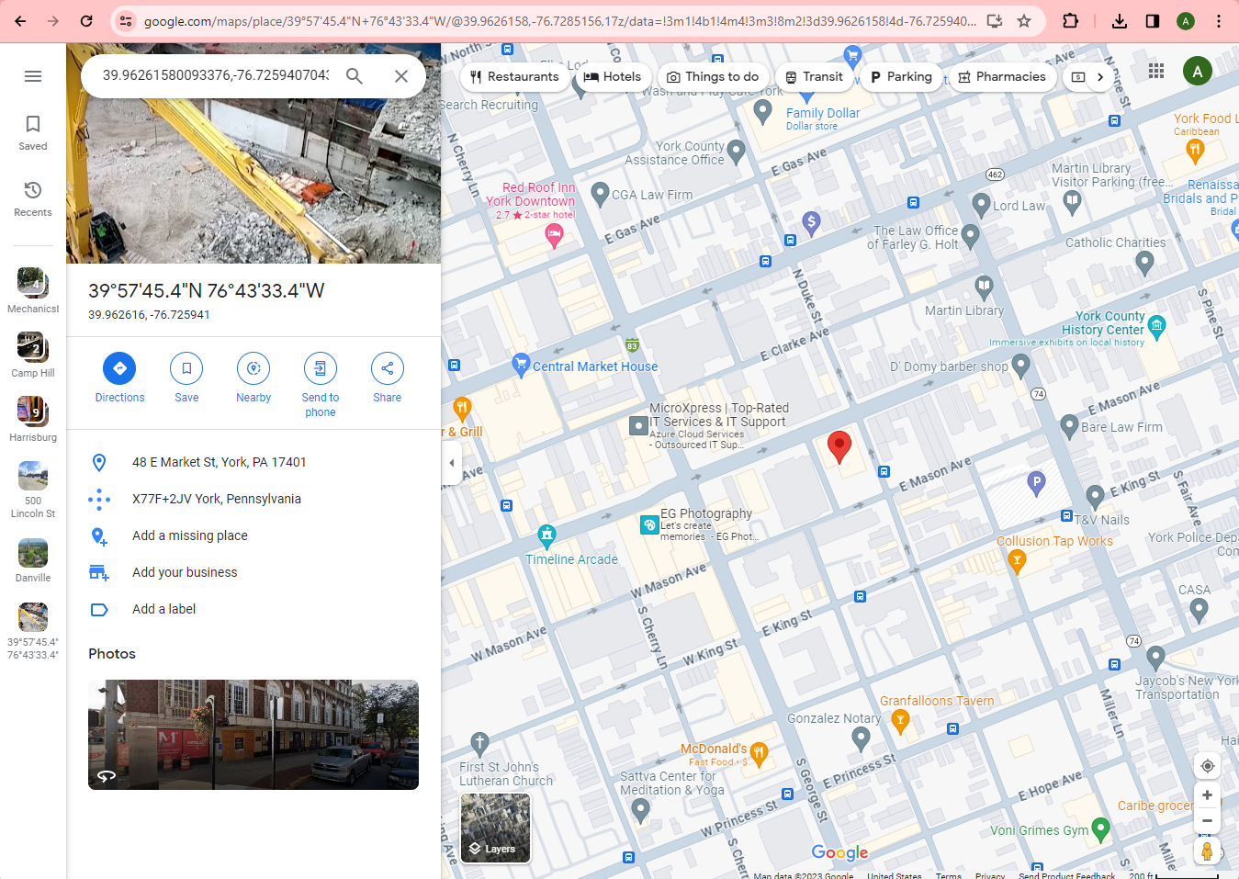

23. What does the browser display? How could an attacker use this for a malicious attack?
A: The browser displays longitude and latitude coordinates of location specified in the QR code

